Assignment: 1 Fall 2025 NS 1001 Applied physics
CLO: 1 Use knowledge of scalars and vectors quantities along with operation of basic operators on it to help them in computer graphics
Q.1. A snow-covered ski slope makes an angle of 35.0° with the horizontal. When a ski jumper plummets onto the hill, a parcel of splashed snow is thrown up to a maximum displacement of 1.50 m at 16.0° from the vertical in the uphill direction as shown in Figure. Find the components of its maximum displacement
(a) parallel to the surface and (b) perpendicular to the surface.

Solution:
Q.2. Consider the three displacement vectors$\vec{A}=(3\hat{i}-3\hat{j)}m$ $\vec{B}=(\hat{i}-4\hat{j)}m,$ and $\vec{C}=(-2\hat{i}+5\hat{j)}m$. Use the component method to determine (a) the
magnitude and direction of $\vec{D}=\vec{A}+\vec{B}+\vec{C}$ and
- the magnitude and direction of$\vec{ E}=-\vec{A}-\vec{B}+\vec{C}$.
Solution:

Q.3. Vector A has a negative x component of 3.00 units in length and a positive y component 2.00 units in length. (a) Determine an expression for A in unit-vector notation. (b) Determine the magnitude and direction of A (c) What vector B when added to A gives a resultant vector with no x component and a negative y component 4.00 units in length?
Solution:
Q.4. The height of a certain hill (in feet) is given by
$$h(x, y)=10(2xy-{3x}^{2}-{4y}^{2}-18x+28y+12)$$
Where y is the distance (in miles) North and x is the distance to east.
- Where is the top of a hill located?
- How high is the hill?

Solution:

Q.5. For given vectors, calculate the divergence.

Q.6. For given vectors, calculate the curl.
Q.7. For given vectors, calculate the gradient.
.
Q.8. Find the directional derivative of the function $∅=x^{2}-y^{2}+2z^{2}$ at point P(1,2,3) in the direction of the line PQ where Q is the point (5, 0, 4).

Solution:
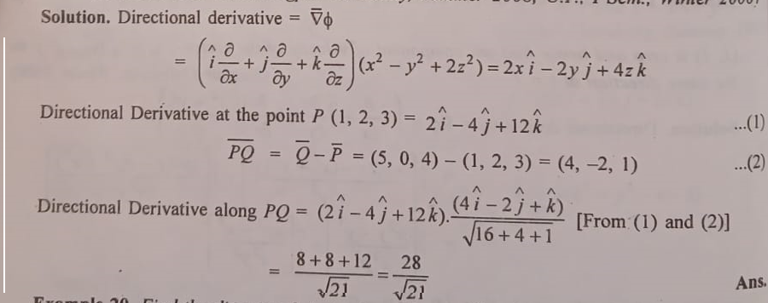
Q.9. The rectangle shown in Figure has sides parallel to the x and y-axes. The position vectors of two corners are A = 10.0 m at 50.0° and B = 12.0 m at 30.0°. (a) Find the perimeter of the rectangle. (b) Find the magnitude and direction of the vector from the origin to the upper right corner of the rectangle.

Solution:
Q.10. Vectors A and B have equal magnitudes of 5.00. The sum of A and B is the vector 6.00 j^. Determine the angle between A and B.
. Solution:

